University Woman’s Club
Annual Meeting and Program

Thursday, March 17th

10:30 – Annual Meeting

10:45 – Presentation and Reading by author
Celeste Tillson, “From a Thought to a Book”

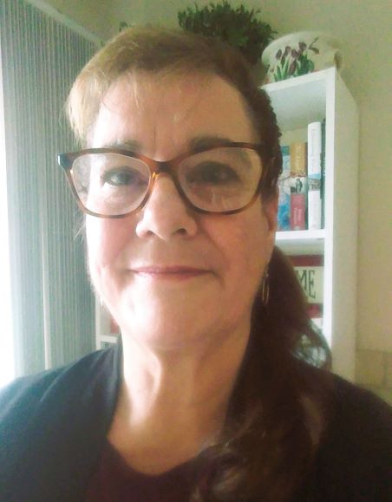

Celeste will read from her NC Coastal trilogy, The Mystery at Oak Island, after talking about her topic. Ms. Tillson visits areas where books for children are not always guaranteed and uses her mysteries to excite and invite children into the wonderful world of reading. There will be time after her remarks for questions. Please bring a friend to this zoom event!

Join us as a member today to hear Celeste speak!

